Linda Mei

FishMarket Mini Report

When there is a fair or even chance meaning no added “weights” to catch the seafood, one can see that the count of weight histogram has an even distribution throughout the histogram. The 58-60 weight is more frequent since there were more crab types in this data. In the count of types histogram with no added “weights,” one can see that the fish, the scallop, and the shrimp are pretty close. Crab is in the slight lead because there were more crab types in this data.

When there is not a fair or even chance meaning that “weights” are added to catch more fish compared to the other seafood, the count of weight histogram does not have an even distribution throughout the histogram. The count of weight histogram goes up and down. In the count of types histogram with added “weights,” one can see more fish are caught compared to the shrimp, the scallop, or the crab in this data.

Histogram (No Added “Weights”)

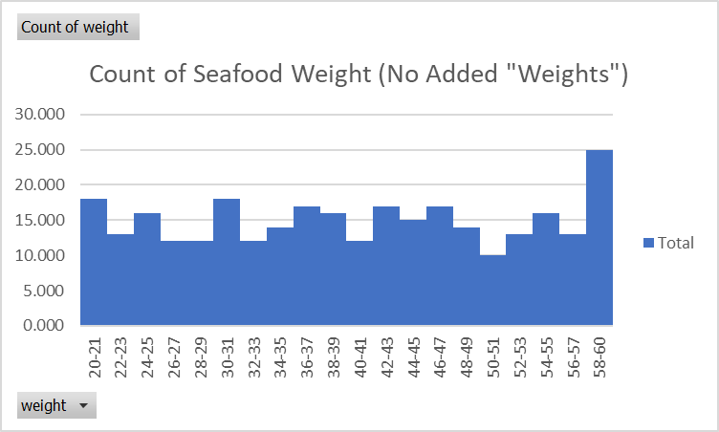

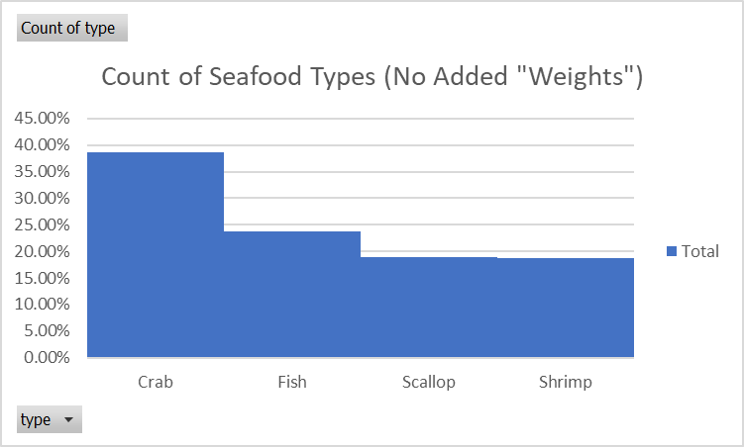

Histogram (Added “Weights”):

